
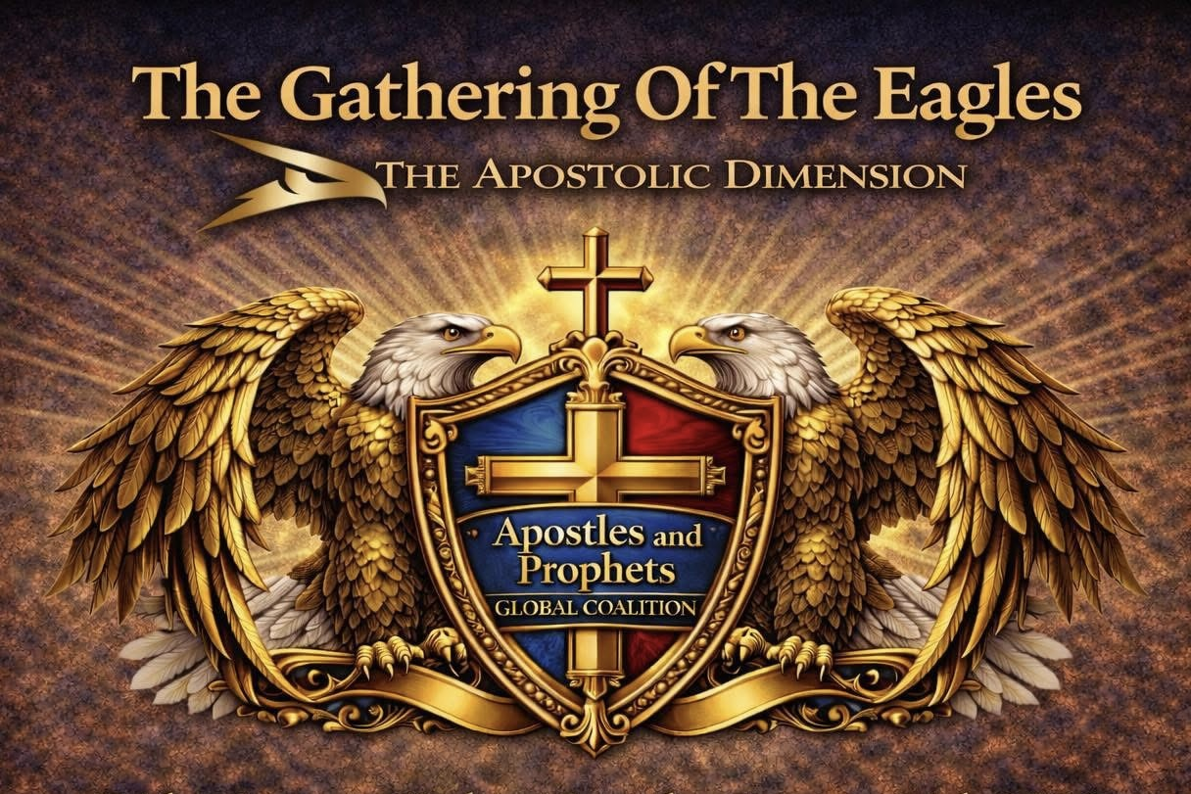
APGC MEMBERSHIP INFORMATION & APPLICATION

Thank you for your interest in this global family of Apostolic and Prophetic leaders.
To become a member of APGC please visit our website and become more familiar with us by reading the pages under About APCG. {Website: APGCUSA.ORG
MEMBERSHIP APPLICATION FEE $55.00 (NON-REFUNDABLE) DUE WITH APPLICATION
Please complete all sections legibly. Print or type. English only.
All fields marked (required) must be completed.
------------------------------------------------------------
PART 1 – PERSONAL INFORMATION
------------------------------------------------------------
Date (required):
____________________________________________________________
First Name (required): ____________________________________________________________
Last Name (required): ____________________________________________________________
Address (required): _________________________________________________________________________________
City __________________ State __________ ZIP Code __________
Country __________________ Phone __________________________
Email Address (required): ____________________________________________________________
Date of Birth (required): _________________________________
Age (required): __________
Gender (required): ________________________________________
Spouse’s Name (if applicable):
____________________________________________________________
Name TWO (2) current APGC Members who agree to nominate you (required):
1. ________________________________________________________
2. ________________________________________________________

------------------------------------------------------------
PART 2 – MINISTRY & NETWORK INFORMATION
------------------------------------------------------------
Name of Ministry / Network / Business:
____________________________________________________________
Your Position (required):
____________________________________________________________
(You will explain how you function as an Apostle or Prophet in Part 3.)
Headquarters Address:
____________________________________________________________
____________________________________________________________
City __________________ State __________ ZIP Code __________
Country __________________ Phone (required) ________________
Email (required):
____________________________________________________________
Website (required):
____________________________________________________________
AFFIRMATION (required):
I affirm that I have read and understand the commitment to APGC,
including Our Why, Purpose, Bylaws, government, operational design,
and Statement of Faith (see About APGC).
I agree with its goals and structure.
Signature: __________________________________________ Date: __________________________________________
------------------------------------------------------------
PART 3 – APOSTLE / PROPHET INFORMATION
------------------------------------------------------------
Name of Applicant (required):____________________________________________________________

====================
APOSTOLIC FUNCTION
====================
Explain how YOU function as an Apostle.
(Use “What Is an Apostle?” as a reference.) (required)
__________________________________________________________________
__________________________________________________________________
__________________________________________________________________
__________________________________________________________________
__________________________________________________________________
__________________________________________________________________
Ministry Address:
____________________________________________________________
____________________________________________________________
City __________________ State __________ ZIP Code __________
Country __________________ Phone __________________________
Website _________________________________________________
Provide the name, website URL, and email of a person with knowledge
of your ministry and to whom you are personally accountable (required):
Name:
____________________________________________________________
Website URL:
____________________________________________________________
Email:
____________________________________________________________
Address Line 1 (required):
____________________________________________________________
City __________________ State __________ ZIP Code __________
Country __________________ Phone __________________________
Email _________________________________________________
Write the names of churches, ministries, or individuals associated
with your apostolic sphere. Provide websites or social media links.
(Addresses not required.) (required)
__________________________________________________________________
__________________________________________________________________
__________________________________________________________________
__________________________________________________________________

====================
PROPHETIC FUNCTION
====================
Explain how YOU function as a Prophet.
(Use “What Is a Prophet?” as a reference.) (required)
__________________________________________________________________
__________________________________________________________________
__________________________________________________________________
__________________________________________________________________
__________________________________________________________________
__________________________________________________________________
Address Line 1 (required):
____________________________________________________________
City __________________ State __________ ZIP Code __________
Country __________________ Phone (required) ________________
Provide the name, phone number, website URL, and email of a person
with knowledge of your ministry and to whom you are personally accountable (required):
Name:
____________________________________________________________
Phone:
____________________________________________________________
Website URL:
____________________________________________________________
Email:
____________________________________________________________
Address Line 1 (required):
____________________________________________________________
City __________________ State __________ ZIP Code __________
Country __________________ Phone (required) ________________
Write the names of churches, ministries, or individuals associated
with your prophetic sphere. Provide websites or social media links.
(Addresses not required.) (required)
__________________________________________________________________
__________________________________________________________________
__________________________________________________________________
__________________________________________________________________
------------------------------------------------------------
SPIRITUAL FOUNDATION
------------------------------------------------------------
Date Born Again:
__________________________________________
Date Filled with the Holy Spirit:
__________________________________________
------------------------------------------------------------
Thank you for your interest in this global family of Apostolic and Prophetic leaders.

